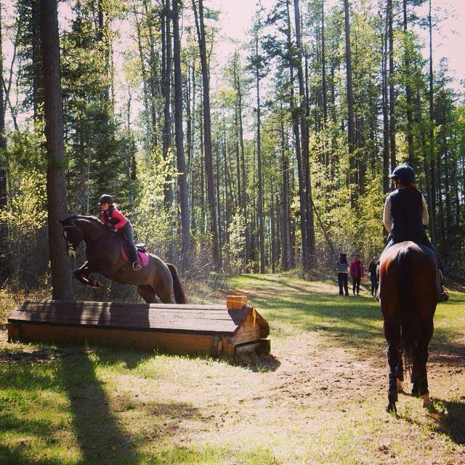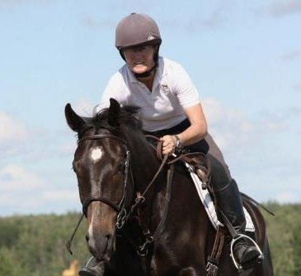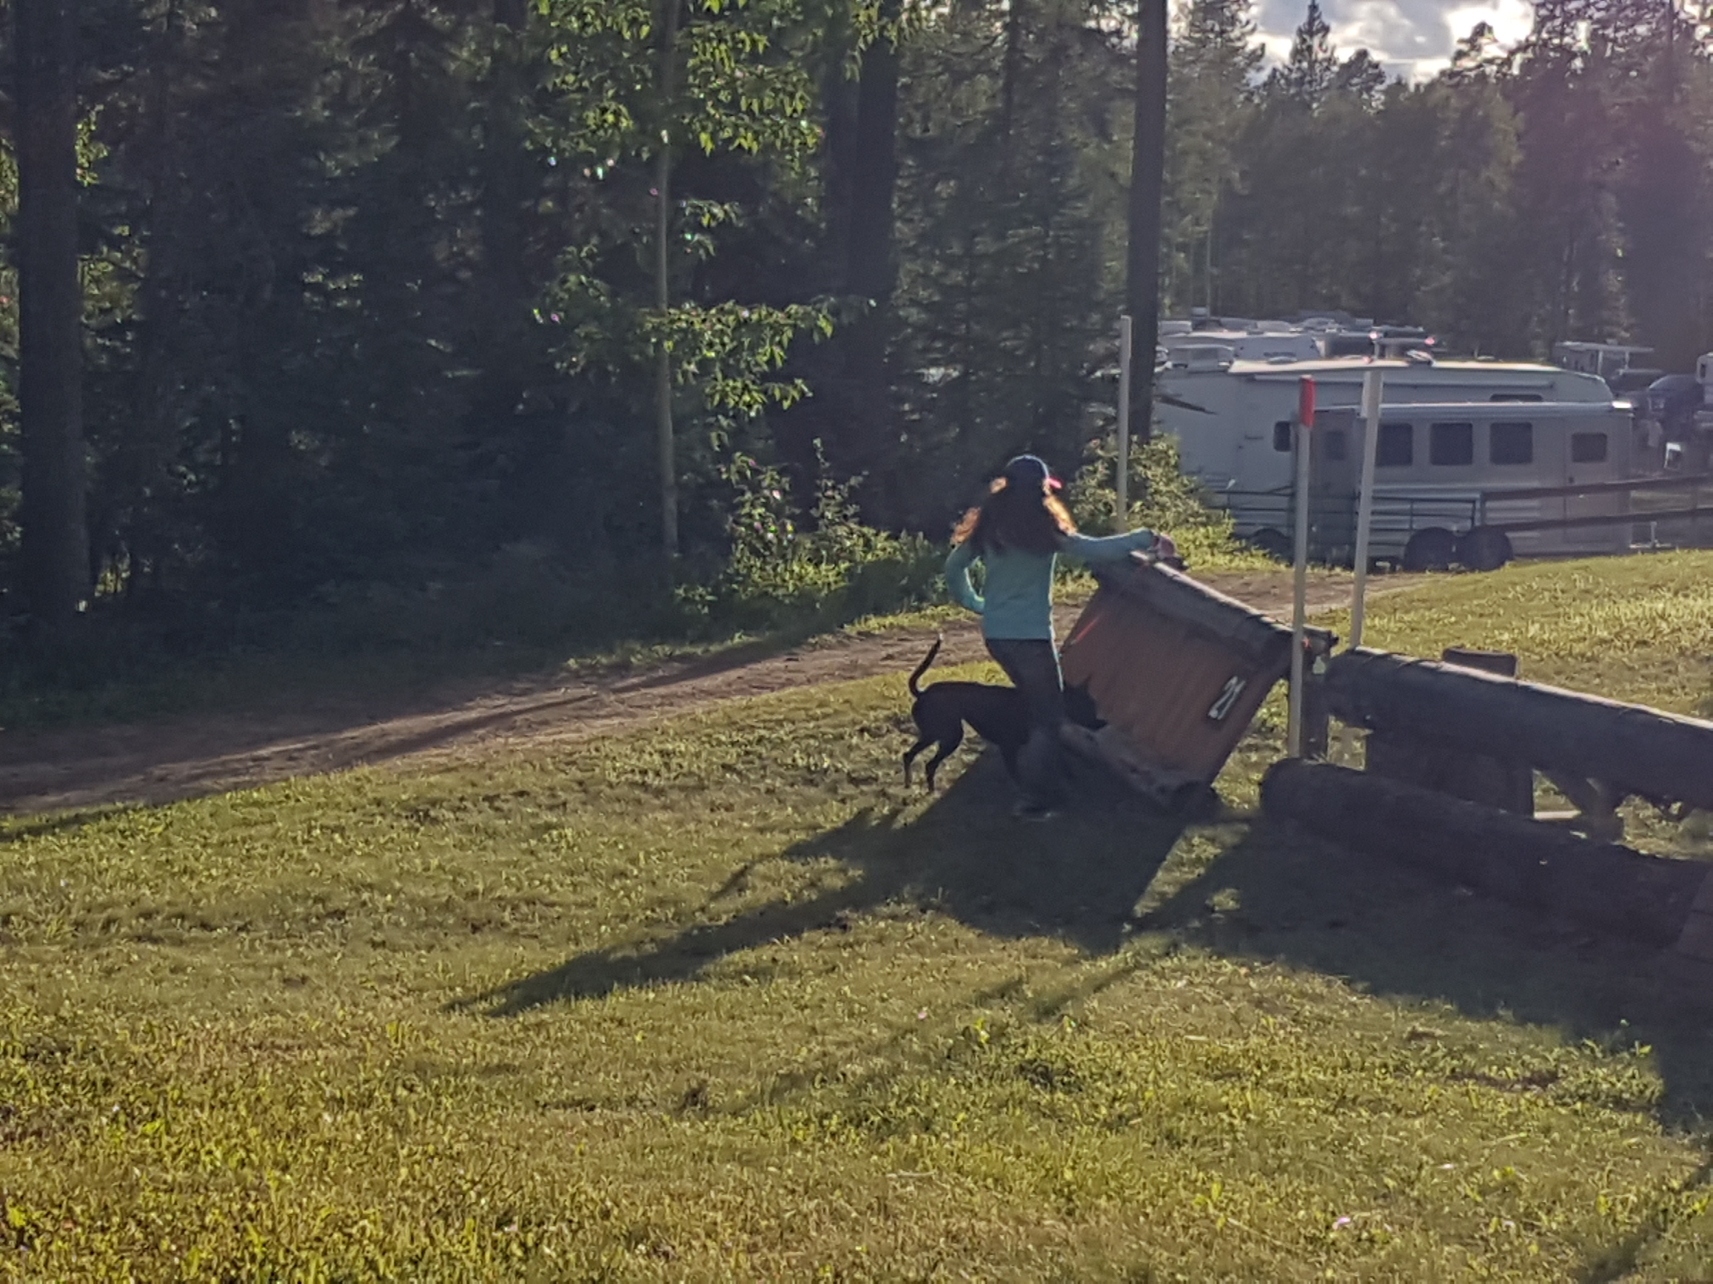
Summer Cross-Country Camp
July 24-26, 2020
Camping and horses – what could be better way to spend the long weekend?! Kick off the Eventing season with tons of fun at a 3 day camp at the lovely Buster Creek facility near Rocky Mountain House. Stadium jumping and cross-country schooling! All levels available. A great head start! Get galloping, get your horse out, get rid of the “sillies” and knock the rust off your cross-country ride. This clinic is always a lot of fun and is excellent preparation for the season.

Instructor: Tricia Dahms- Equine Canada High Performance coach, Team Canada member- 1999 Pan Am Games, Rolex, Kentucky CCI***, Short-listed for 2000 Sydney Olympics, 2012 Equine Canada High Performance Coaching Award

Clinic: $350.00 (includes GST) Indoor stabling -$25/night and paid separately to Prentis Creek Equestrian Club on arrival. Clinic goes rain or shine. Prentiss Creek is charging an additional $25.00 this year if you ride or work your horse the night prior to the clinic so in the interests of rider safety and preparation, we have simply booked the extra day so come and ride your horse Friday as early as you would like!

Registrations: will be accepted on a first come, first served basis. Complete registration form and send to email address below along with payment. Book early as spaces fill quickly for this very popular clinic.
Your horse MUST have a negative coggins test for this venue before they will allow you to unload. Payment for the clinic fee can be made by etransfer to the email address below or via credit card or cheque. Payment for stabling is to be made to Prentiss Creek and may be brought to the clinic. Refunds for any reason will only be made if your place can be filled from a wait list.
Basic camping:-no charge. RV spot with plug-in, available on a paid basis. Campfire Saturday evening. Potluck dinner. Sign-up sheet will be sent out to bring your specialty dish. Kitchen facilities NOT available this year and no potluck dinner, but please bring your own food and we will have a socially distanced campfire on Saturday night. Guitars and musicians welcome.

Please contact Sandridge Stables to register:
22335 Twp Road 520, Sherwood Park, AB, T8C 1E2
780-922-7383 Office, 780-271-2106 Cell
tricia@sandridgestables.ca

